**Rapid Games Prototyping 3**

**Tutorial - Game Design Document**

**Objective**

This is a prototype with a basic 2D platform mechanic, the main objective in this game is to collect pickup on the map before the timer runs out. If the player finishes collecting all the pickups, the player wins. On the opposite, the player will be asked to challenge again.

**Gameplay Mechanics**

The game core loop with be move and jump, collect pickup gain score and rechallenge to aim for higher score. As is aiming for player to keep on challenging in this game, there will be a mechanics on time countdown at the top shows in the game screen plus a score obtain in the game during process. For 2D platform game, it requires player to run through map to reach the goal, therefore, there will be a checkpoint system in the game which location player to the triggered checkpoint when they accidentally fall out the map. Concerning to have a game over scene when player finish the challenge and provide option to re-challenge or not.

**Level Design**

The 2D platform level will be a map with pickup item for player to collect in the game. There will be different item with different point. The player will need to collect the items to reach their best score in the game. Concerning to be obstacles for example, moving the platform in the level might assist or prevent the player to run through the level. As to make the level increase the difficulty, the countdown system will be set to a short time display in seconds, so the player will need to have well control to run through the map.

**Technical**

**Scenes**.

The scene in unity will be a main menu to start the game. Afterward, the player will enter the game and there will display two sets of UI at the top of the scene. The countdown timer and a score of players obtain during the process of the scene. When the player finishes the game, there will be an in-scene game over UI appear which asks the player to rechallenge or not. Pickup will locate in the level for player to collect, they had different colours for player to define and also means different points player will obtain. There will be some hidden space for player to discover, for reward there will be rare pickup located.

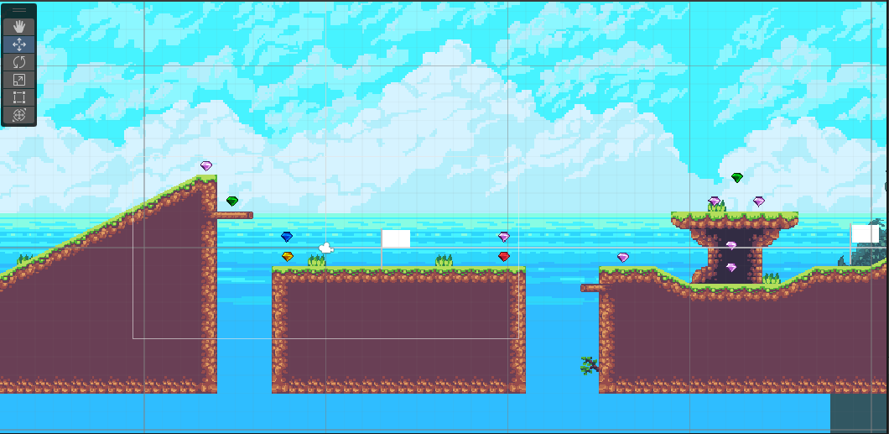

Point system:

The colours of the Rupee signifies its worth:

* Green Rupee: 1
* Blue Rupee: 5
* Yellow Rupee: 10
* Red Rupee: 20
* Purple Rupee: 50
* Orange Rupee: 100
* Silver Rupee: 200

**Controls**

Control will be based on keyboard input only, WASD key for character movement and space key for jumping.